Chemical Thermodynamics

Select the alternative that correctly answers the following questions.

1. Which of the following is endothermic?

a) Burning magnesium metal.
b) Condensation of water.
c) Melting candle wax.
d) Adding concentrated acid to water.

2. Which of the following statements is INCORRECT?

a) An exothermic reaction releases heat and has a negative ΔH.
b) In an exothermic reaction the temperature of the surroundings would decrease.
c) In an exothermic reaction the products have a lower enthalpy (heat content) than the reactants.
d) An example of an exothermic reaction is the combustion of methane.

3. Which of the following graphs shows enthalpy changes involved in an endothermic reaction?
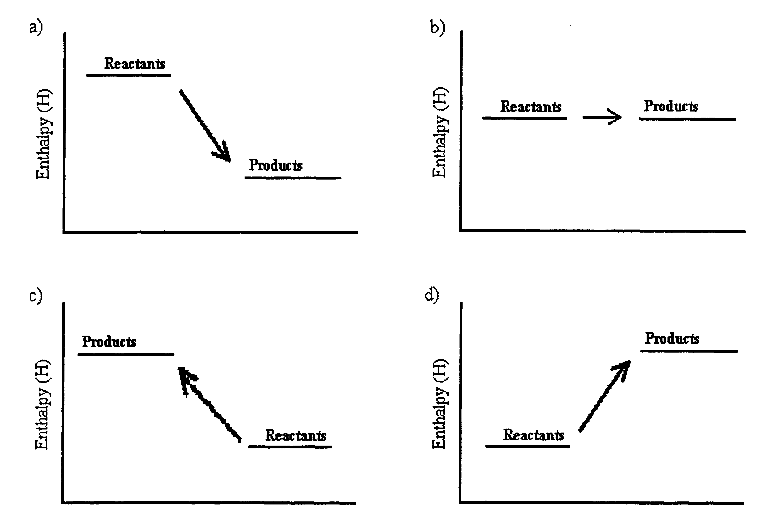

4. Consider the following equations:

I. C₄H₁₀(l) + 6O₂(g)  4CO₂(g) + 5H₂O(l) ΔH. = -2727 kJ
II 6CO₂(g) + 6H₂O(l) C₆H₁₂O₆(s) 6O₂(g) ΔH = +2816 kJ
III. CO(g) + ½O₂(g) CO₂(g) ΔH = -283 kJ moL⁻¹
IV. H₂(g) + ½O₂(g) H₂O(l) ΔH = -286 kJ
V. C₃H₈(g) 3C(s) + 4H₂(g) ΔH = +104 kJ

Which equations are exothermic

a) I, III and IV
b) I and IV
c) III and V
d) II and V

5. When solid ammonium chloride dissolves in water, there is a decrease in the temperature of the solution. This type of reaction is called

a) an endothermic reaction.
b) a neutralisation reaction.
c) an exothermic reaction.
d) a precipitation reaction.

6. Use the information below to calculate ΔH for the reaction:
C₂H₆(g) + ⁷/₂O₂(g) 2CO₂(g) + 3H₂O(g)

Heats of Reaction for Formation of Compounds at 25ºC and 101.3 kPa

C(s) + O₂(g) CO₂(g) ΔH = -393 kJ moL⁻¹
H₂(g) + ½O₂(g) H₂O (g) ΔH = -242 kJ moL⁻¹
2C(s) + 3H₂(g) C₂H₆ (g) ΔH = -85 kJ moL⁻¹

ΔH for the combustion of 1 mole of C₂H₆(g) is

- -720 kJ
- -1427 kJ
- -1597 kJ
- -550 kJ

7. The neutralization reaction between hydrochloric acid and sodium hydroxide may be represented as:

HCl(aq) + NaOH(aq) NaCl(aq) + H₂O(l) + 57.2kJ

In this reaction , you would expect the temperature of the resulting solution to

a) increase, due to the reaction being endothermic.
b) increase, due to the reaction being exothermic.
c) decrease, due to the reaction being endothermic.
d) decrease, due to the reaction being exothermic.
e) There is insufficient information to predict a change to the temperature of the solution.

8. Study the following two equations:

I. H₂(g) + ½O₂(g) H₂O(g) ΔH = -242 kJ
II. H₂(g) + ½O₂(g) H₂O(l) ΔH = -285 kJ

The best explanation for the difference in the values of ΔH for these two reactions is

a) More heat is given off in equation I because the water is in gaseous form.
b) Water vapour has greater enthalpy than liquid water so reaction II releases more heat energy to its surroundings.
c) Water in the liquid phase has more stored energy then water vapour so reaction II releases less heat energy to its surroundings.
d) Water in the liquid phase stores less energy than water vapour and so releases less heat energy to its surroundings.

9. The following diagram shows the changes in Potential Energy for the reaction :
N₂(g) + O₂(g) 2NO(g)

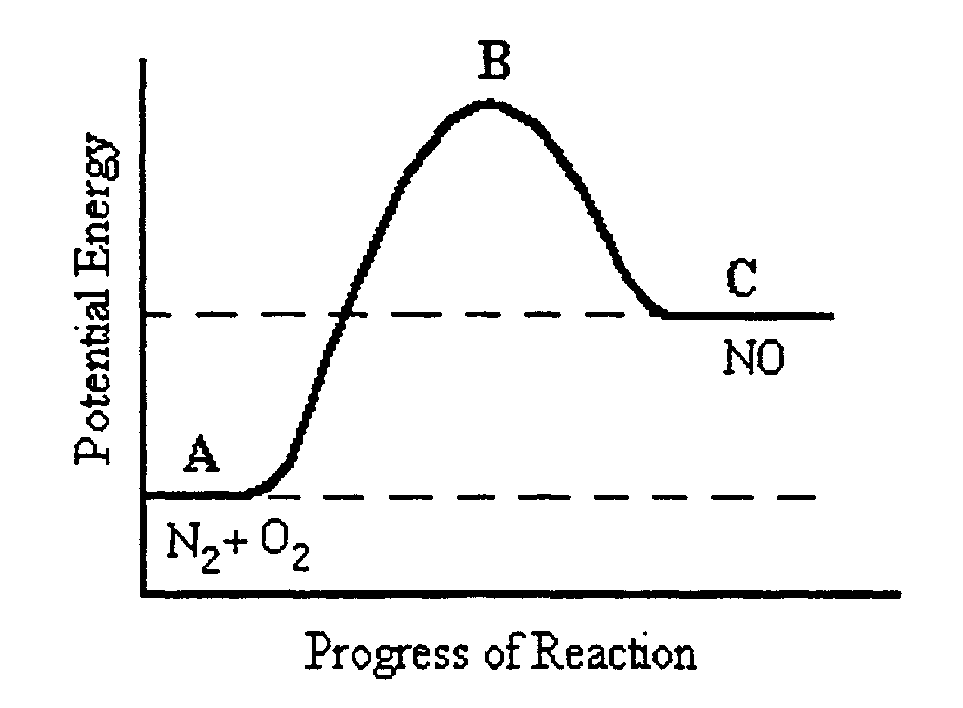

9. [cont’d] Which of the following statements is FALSE?
a) The reaction is endothermic with ΔH = C - A.
b) The reactants have less potential energy than the products.
c) B represents the transitional state where intermediate compounds are formed in the course of the reaction.
d) The activation energy would be equal to B – C.
- Addition of a suitable catalyst would lower the potential energy of B.

10. Consider the reaction between magnesium metal and dilute hydrochloric acid:

Mg(s) + 2HCl(aq) MgCl₂(aq) + H₂(g)

A student wants to see what effect temperature has on the rate of this reaction. He performs this experiment at two different temperatures and measures the volume of hydrogen gas produced over time.

Using your knowledge of reaction rates, which graph best represents the expected results of this experiment?

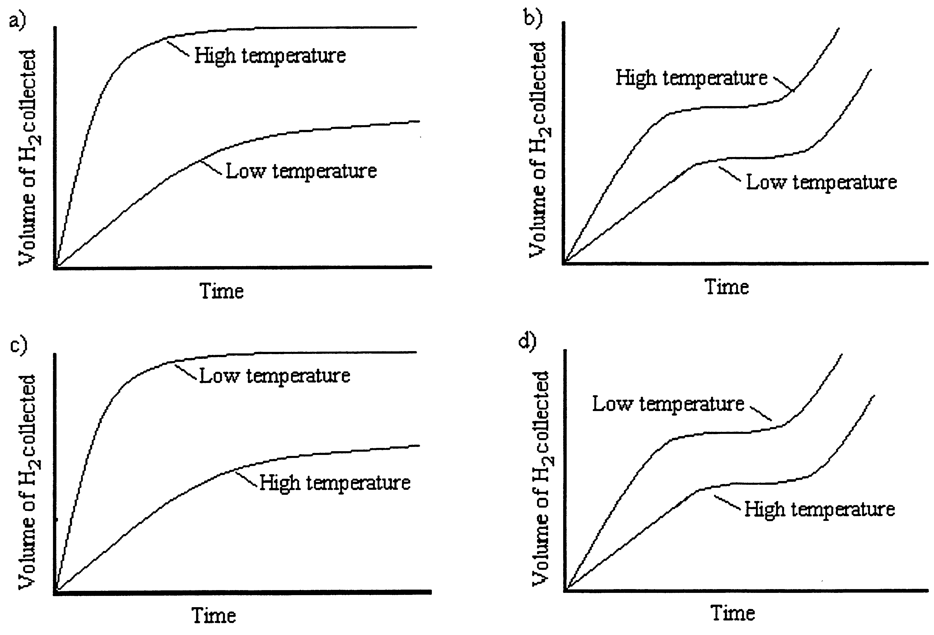

11. Molar Heat of Fusion refers to

a) the amount of energy released when a mole of a substance undergoes combustion.
b) the amount of heat released during nuclear fusion of one mole of a substance.
c) the amount of heat required to boil one mole of a substance at its boiling point.
d) the amount of heat released when one mole of a substance changes phase from a gas to a liquid.
e) the amount of heat required to melt one mole of a substance at its melting point.

12. The table below shows the molar heats of fusion and vapourization of five common substances.

Substance | molar heat of fusion  (kJ mol⁻¹) | molar heat of vapourization (kJ mol⁻¹)
Hydrogen | 0.1 | 0.4
Methane | 1 | 8
Water | 6 | 41
Ammonia | 6 | 23
Sodium chloride | 28 | 170

Which of the following, lists these substances in order of increasing boiling point?

a) Sodium chloride, water, ammonia, methane and hydrogen.
b) Hydrogen, methane, ammonia, water and sodium chloride.
c) Hydrogen, methane, water, ammonia and sodium chloride.
d) Methane, hydrogen, water, ammonia and sodium chloride.

